Generative Visual Manipulation on the Natural Image Manifold

1 Introduction

There are two reasons preventing these advances from being useful in practical applications at this time. First, the generated images, while good, are still not quite photo-realistic (plus there are practical issues in making them high resolution). Second, these generative models are setup to produce images by sampling a latent vector-space, typically at random.

We show three applications based on our system: (1) Manipulating an existing photo based on an underlying generative model to achieve a different look (shape and color); (2) Generative transformation" of one image to look more like another; (3) Generate a new image from scratch based on user's scribbles and warping UI.

2 Prior Work

Image editing and user interaction:

Image editing is a well established area in computer graphics where an input image is manipulated to achieve a certain goal specified by the user. Common artifacts include unrealistic colors, exaggerated stretching, obvious repetitions and over-smoothing.

Image morphing:

Image morphing:

Traditional morphing methods combine an intensity blend with a geometric warp that requires a dense correspondence.

Natural image statistics:

Neural generative models:

Generative adversarial networks (GAN), proposed by Goodfellow, learn a generative network jointly with a second discriminative adversarial network in a mini-max objective. The discriminator tries to distinguish between the generated samples and natural image samples, while the generator tries to fool the discriminator producing highly realistic looking images.

3 Learning the Natural Image Manifold

Generative Adversarial Networks:

GAN as a manifold approximation:

Traversing the manifold:

4 Approach

Figure 1 illustrates the overview of our approach. Given a real photo, we first project it onto our approximation of the image manifold by finding the closest latent feature vector z of the GAN to the original image. Then, we present a real time method for gradually and smoothly updating the latent vector z so that it generates a desired image that both satisfies the user's edits (e.g. a scribble or a

warp; more details in Section 5) and stays close to the natural image manifold. Unfortunately, in this transformation the generative model usually looses some of the important low-level details of the input image. We therefore propose a dense correspondence method that estimates both per-pixel color and shape changes from the edits applied to the generative model. We then transfer these changes to the original photo using an edge-aware interpolation technique and produce the final manipulated result.

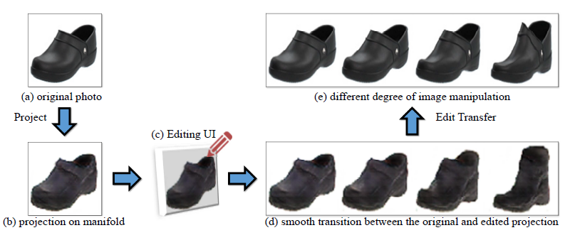

4.1 Projecting an Image onto the Manifold

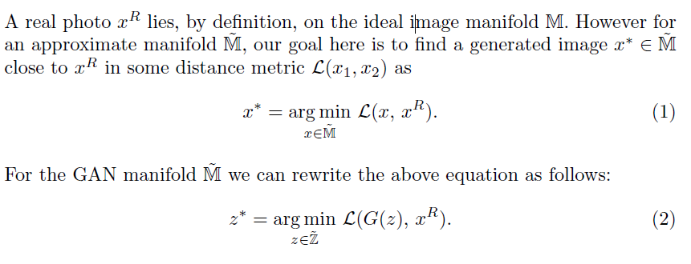

Projection via optimization:

Projection via a feedforward network:

A hybrid method:

4.2 Manipulating the Latent Vector

4.3 Edit Transfer

5 User Interface

5.1 Editing constraints

6 Implementation Details

Network architecture:

Computational time:

7 Results